

**Faculty of Engineering & Technology Electrical & Computer Engineering Department**

**Communication Lab - ENEE4113**

**Experiment 5: Phase Modulation**

**Prelab #4**

**Student Name**: Maha Maher Mali

**Student ID**: 1200746

**Instructor**: Dr. Ashraf Al_Rimawi

**Teacher Assistant**: Eng. Mohammed Battat

**Section**: 4

**Date**: 10-8-2023

Contents

Software Prelab (Simulink MATLAB) 5

Extract the message signal m(t) from s(t) 5

Plot 5 cycle from Message signal m(t) and s(t) 6

Block Diagram 6

Message Signal 6

Modulated signal s(t) 7

Differentiate s(t) with respect to t and plot ds(t)/dt 9

By Hand Solution 9

Using Simulink 9

Apply ds(t)/dt to an ideal envelope detector 12

By Hand Solution 12

Extract message signal by using phase-locked loop (PLL) 13

Block Diagram 13

In time Domine 13

In frequency Domine 14

Extract the message signal by using the envelop detector 15

Block Diagram 15

In Time Domine 15

In frequency Domine 16

**Table of Figures**

Figure 1: Steps to Extract the message signal m(t) from s(t) 5

Figure 2: PM Modulation Block Diagram 6

Figure 3: Message Signal in Time domine 6

Figure 4: Frequency Domine 7

Figure 5: Modulated signal In Time Domine 8

Figure 6: Modulated signal in frequency Domine 8

Figure 7: Differentiate s(t) 9

Figure 8: Block Diagram to Differentiate s(t) 9

Figure 9: Differentiate s(t) in time domine 10

Figure 10: Differentiate s(t) in frequency domine 10

Figure 11: Apply ds(t)/dt to an ideal envelope detector 12

Figure 12: PM Demodulation by PLL Block Diagram 13

Figure 13: Demodulated signal in time domine 13

Figure 14: Demodulated signal in frequency domine 14

Figure 15: PM Demodulation by using the envelop detector Block Diagram 15

Figure 16: Demodulated signal in time domine 15

Figure 17: Demodulated signal in time domine 16

# Software Prelab (Simulink MATLAB)

## Extract the message signal m(t) from s(t)

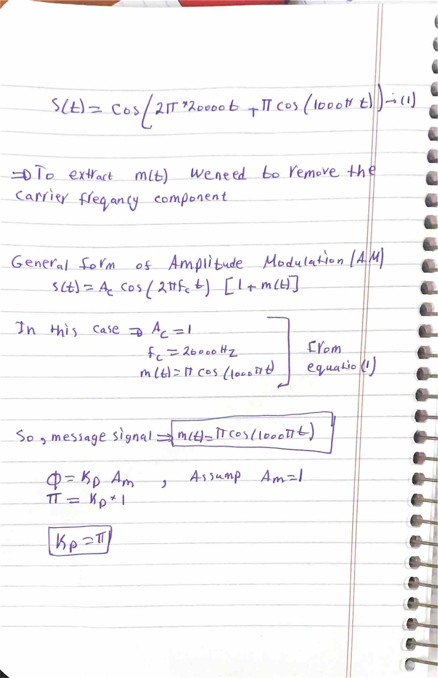

Figure 1: Steps to Extract the message signal m(t) from s(t)

## Plot 5 cycle from Message signal m(t) and s(t)

### Block Diagram

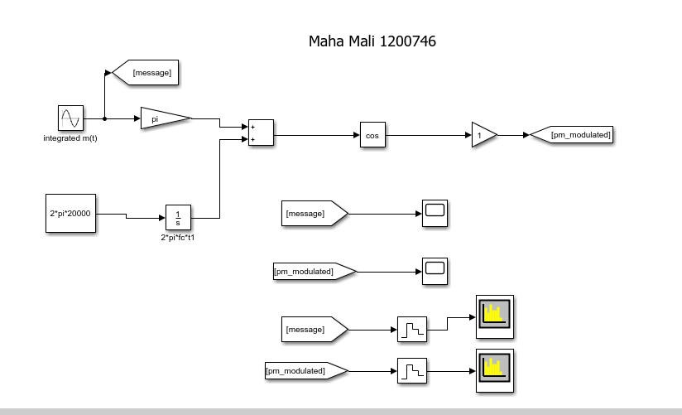

Figure 2: PM Modulation Block Diagram

### Message Signal

#### Time Domine

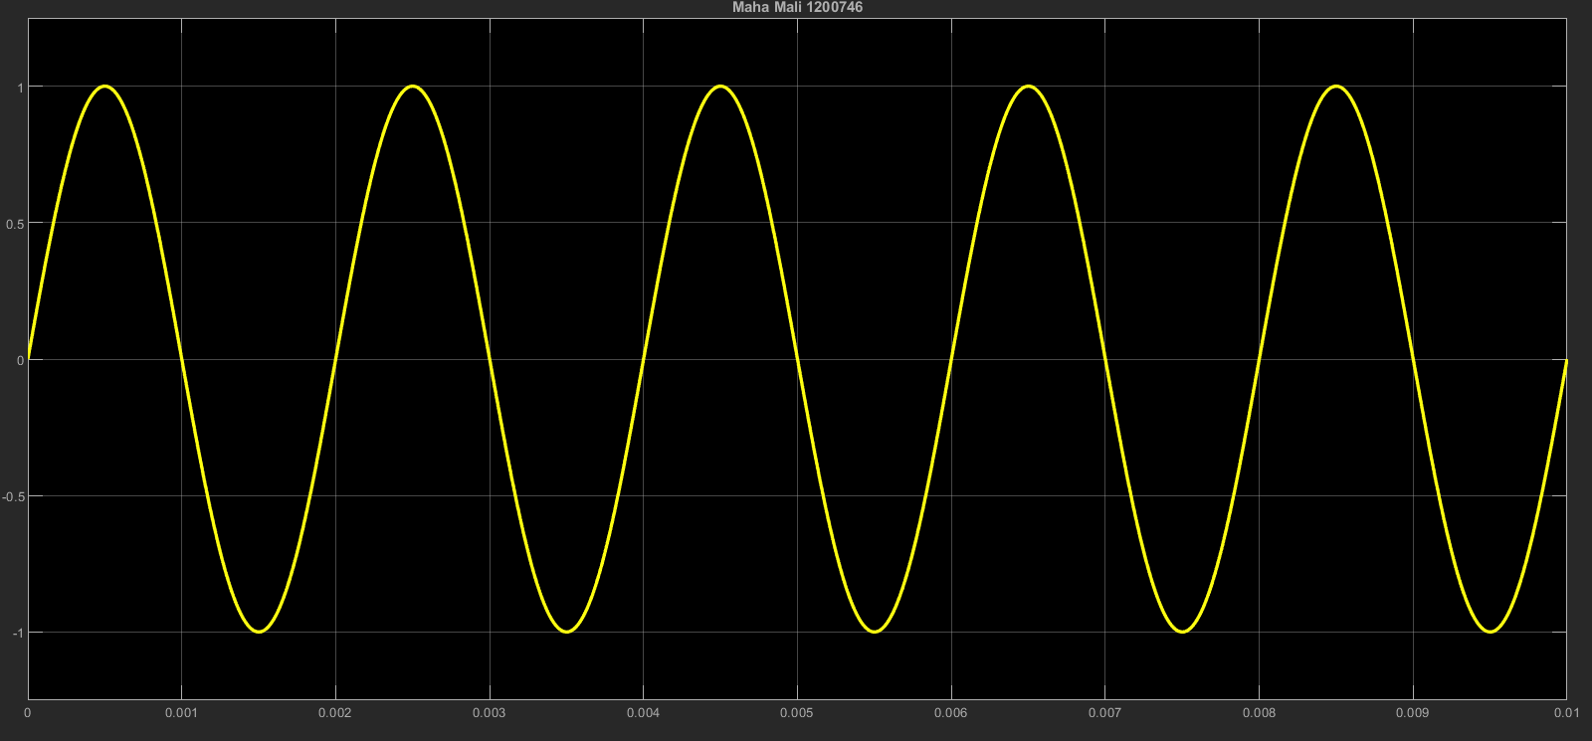

Figure 3: Message Signal in Time domine

From this graph we notice that we got the m(t) that we calculate it by hand with amplitude 1.

#### Frequency Domine

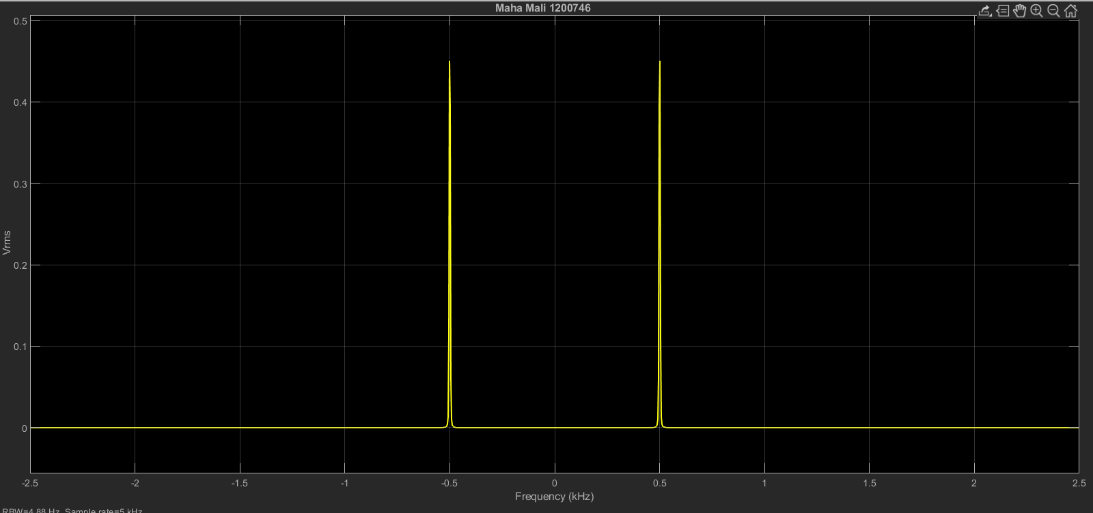

Figure 4: Frequency Domine

The figure 5 show that we have two delta one at 500 Hz, and another on -500 Hz , according the equation for m(f).

### Modulated signal s(t)

#### Time Domine

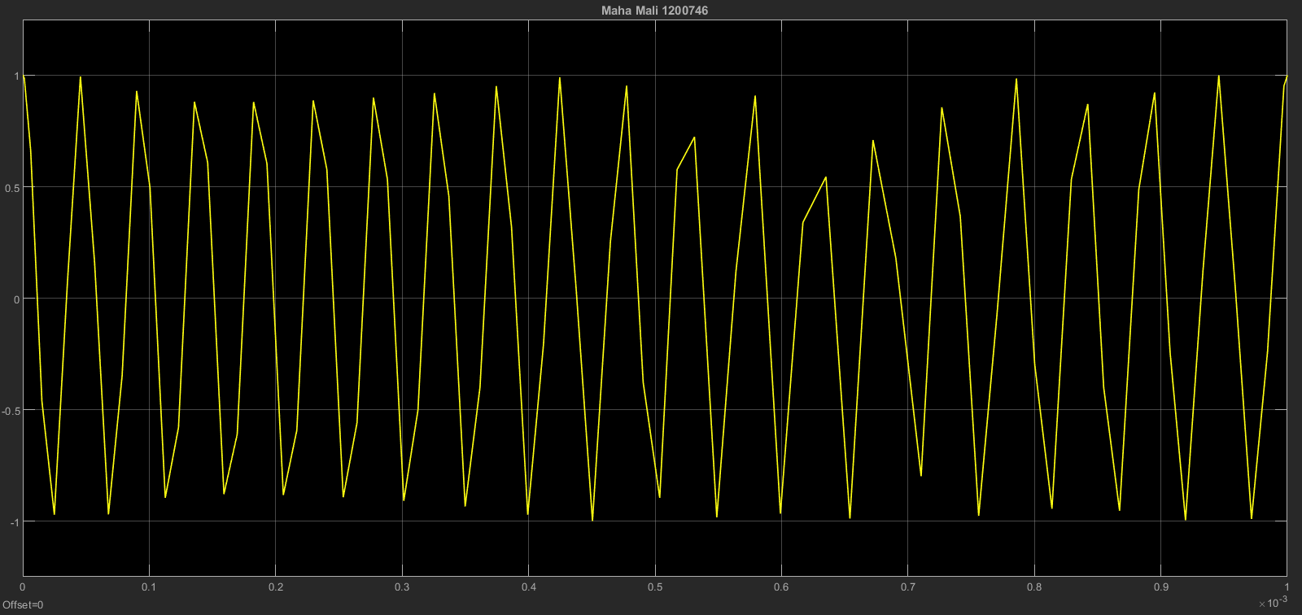

Figure 5: Modulated signal In Time Domine

#### Frequency Domine

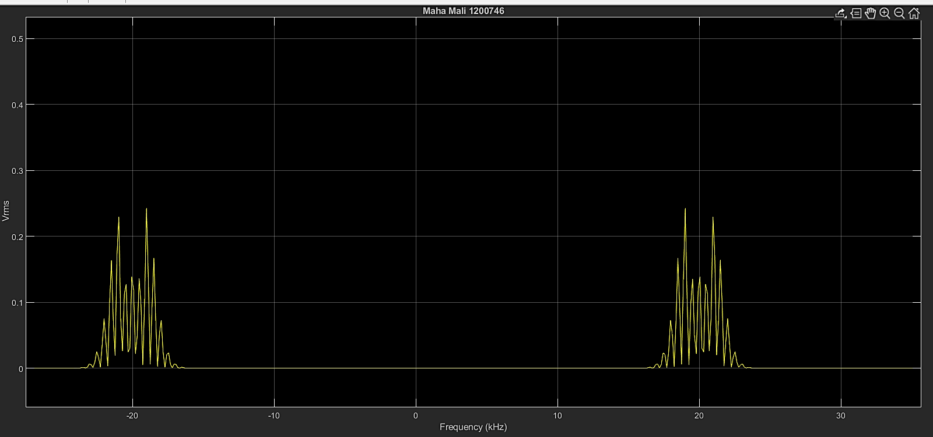

Figure : Modulated signal in frequency Domine

## Differentiate s(t) with respect to t and plot ds(t)/dt

### By Hand Solution

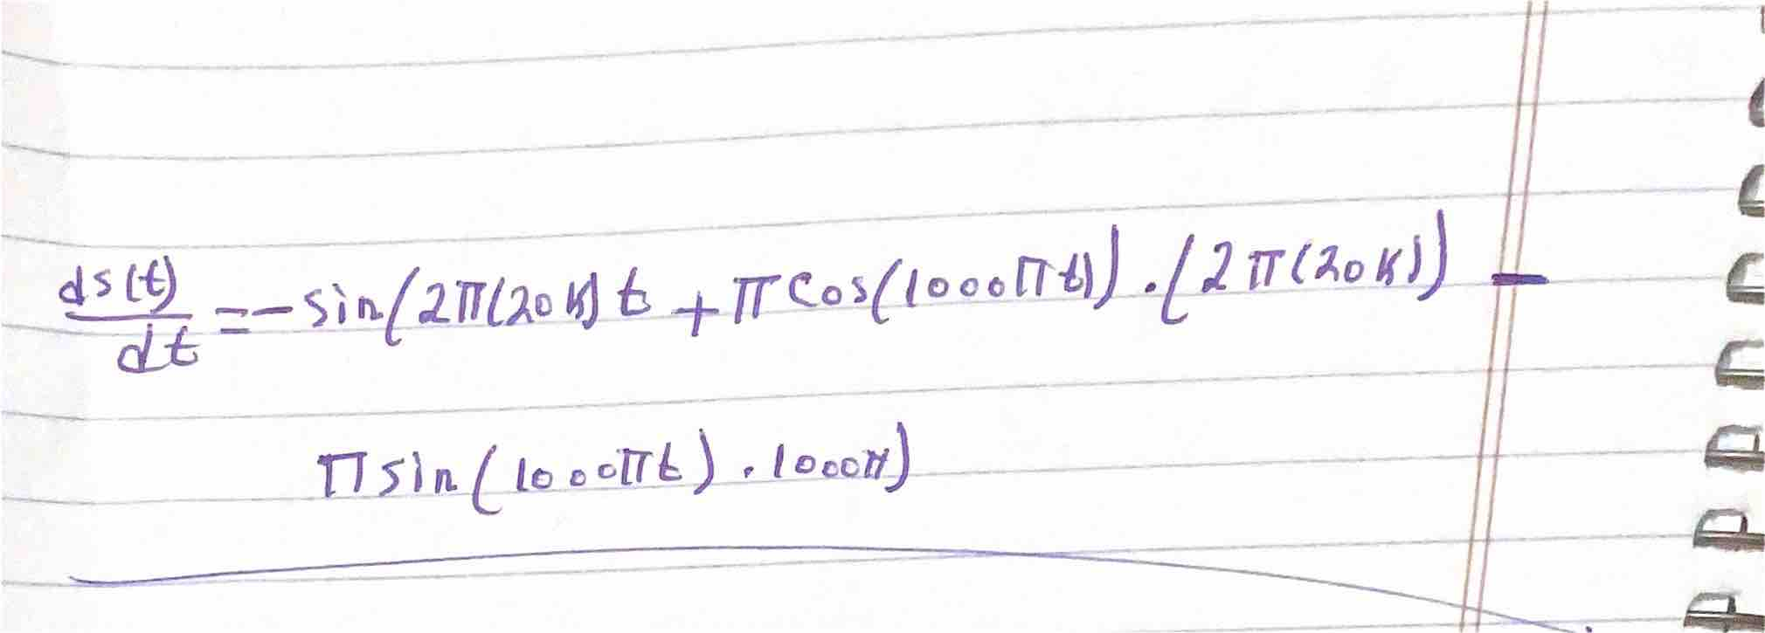

Figure 7: Differentiate s(t)

### Using Simulink

#### Block Diagram

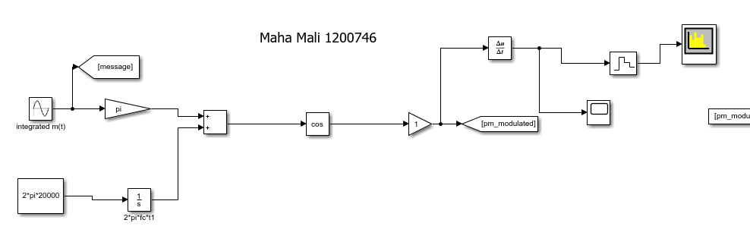

Figure 8: Block Diagram to Differentiate s(t)

#### Time domine

Figure 9: Differentiate s(t) in time domine

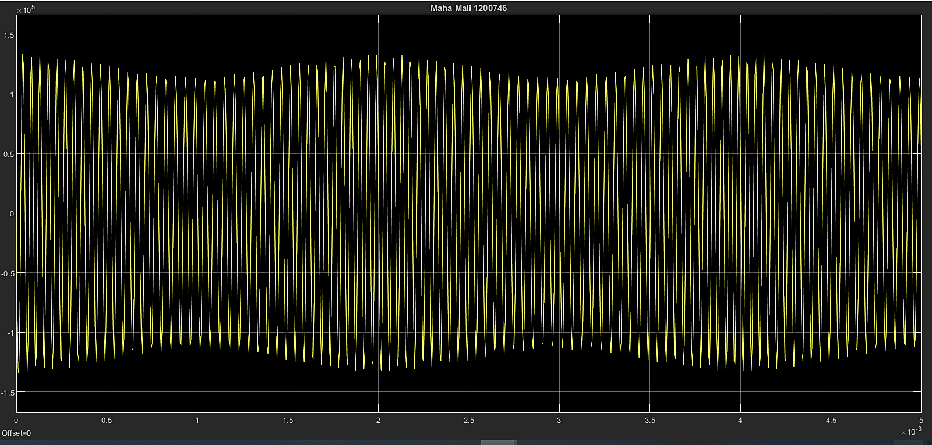

##### Frequency domine

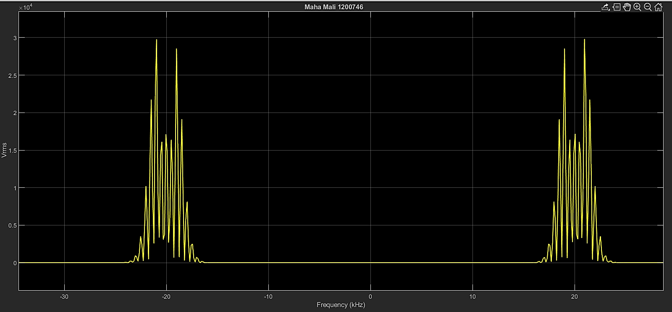

Figure 10: Differentiate s(t) in frequency domine

Differentiating the phase-modulated waveform s(t) = cos (2*pi*20000t+pi*cos(1000*pi*t)) with respect to time yields a signal with amplitude variations linked to the frequency of the message signal. This transformation resembles amplitude modulation (AM), where the message signal modulates the carrier's amplitude. The resulting signal takes on AM-like characteristics due to the changing amplitudes associated with the message frequency, demonstrating the interconnected nature of different modulation techniques within the context of signal processing.

## Apply ds(t)/dt to an ideal envelope detector

### By Hand Solution

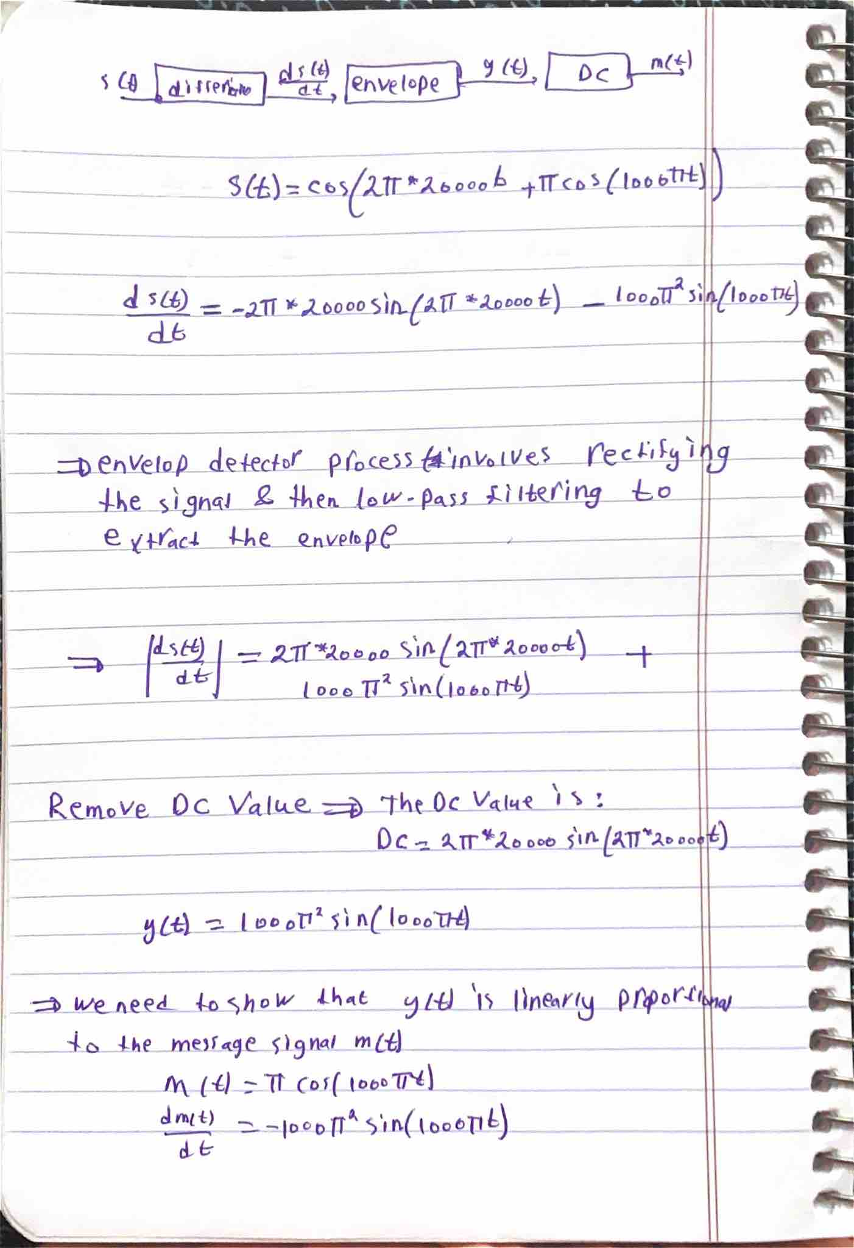

Figure 11: Apply ds(t)/dt to an ideal envelope detector

## Extract message signal by using phase-locked loop (PLL)

### Block Diagram

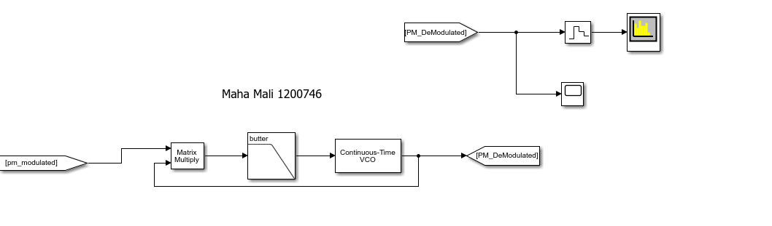

Figure 12: PM Demodulation by PLL Block Diagram

### In time Domine

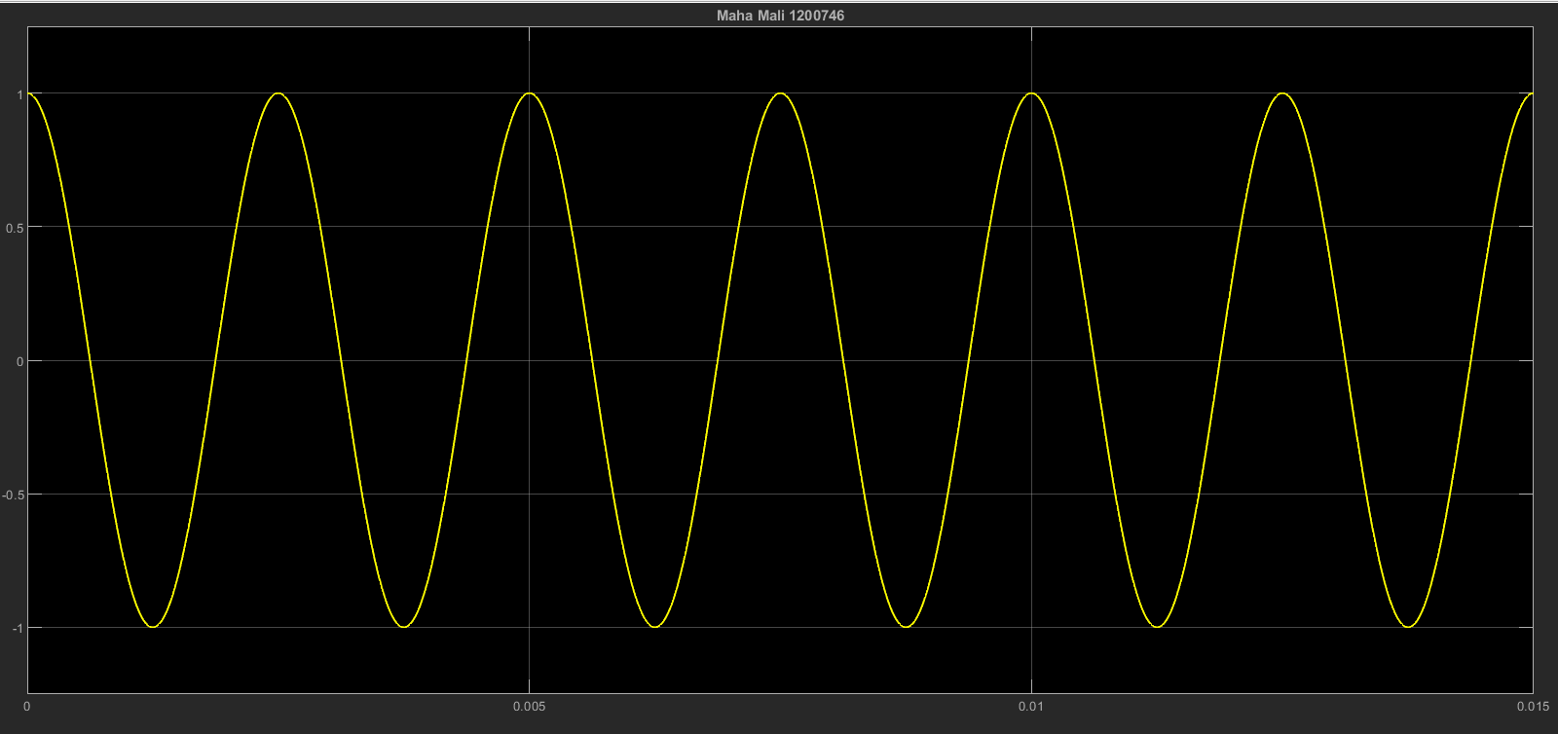

Figure 13: Demodulated signal in time domine

The figure 13 shows the amplitude of the demodulated signal has the same amplitude of message signal which is 1.

### In frequency Domine

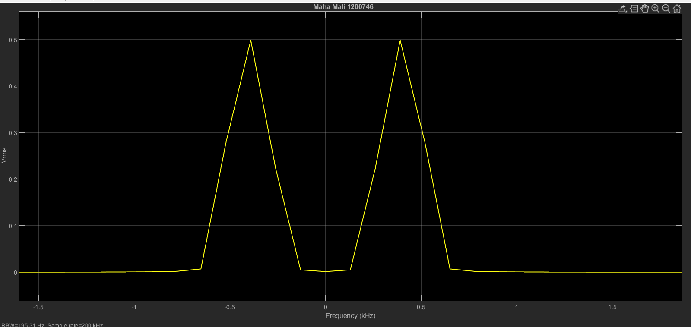

Figure 14: Demodulated signal in frequency domine

The figure show that the demodulated signal has the same frequency of message signal which is 500 Hz.

## Extract the message signal by using the envelop detector

### Block Diagram

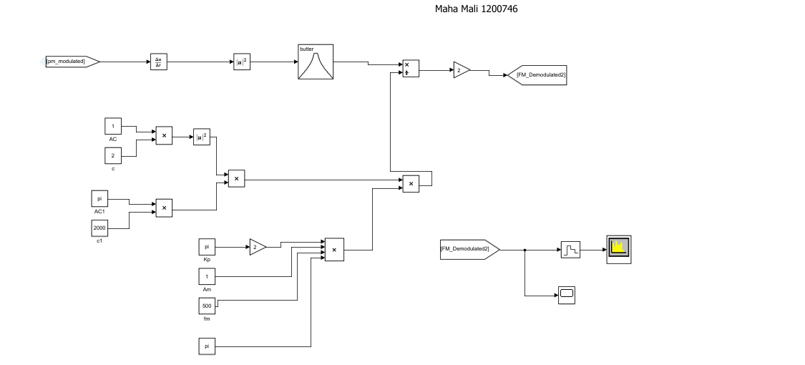

Figure 15: PM Demodulation by using the envelop detector Block Diagram

### In Time Domine

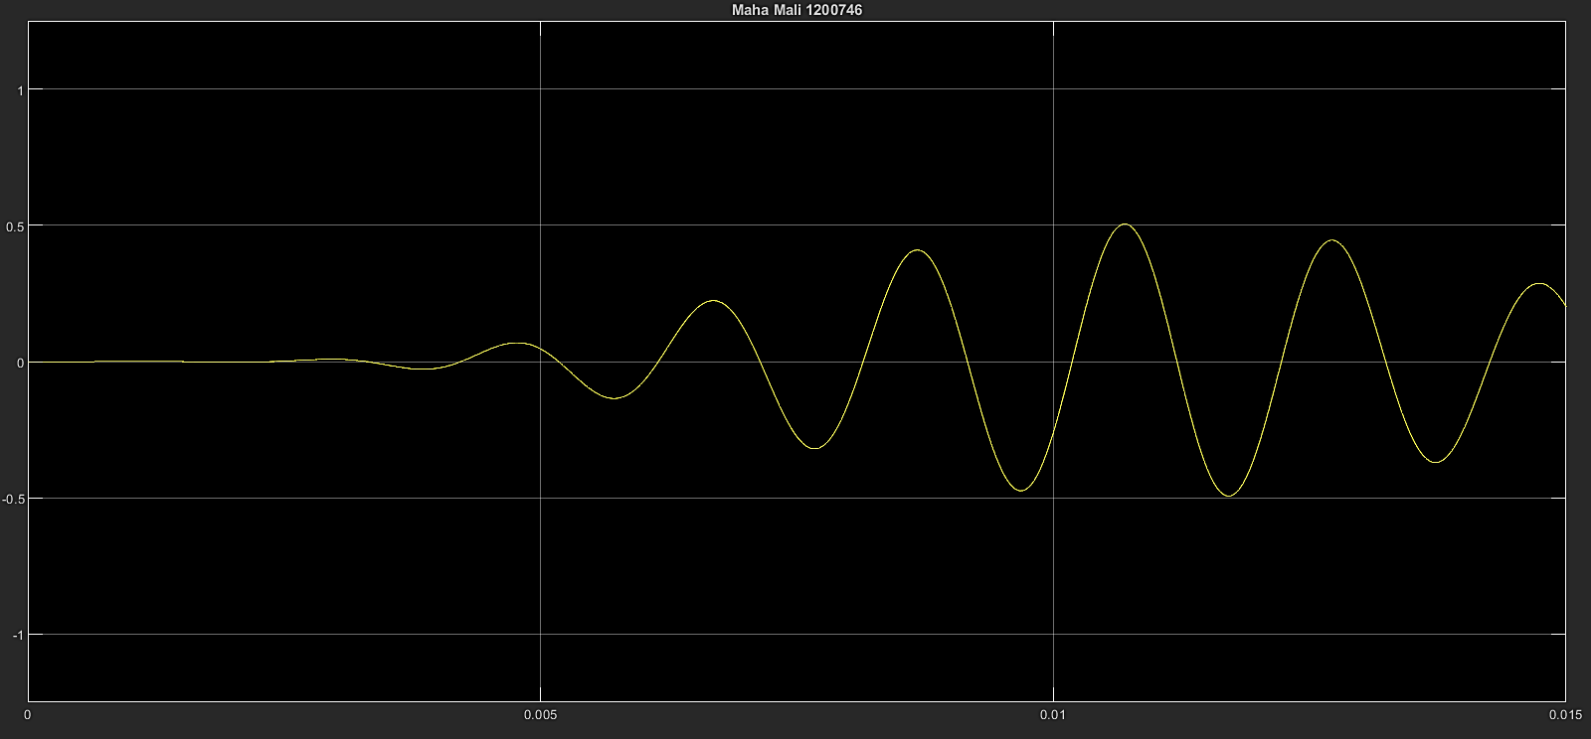

Figure 16: Demodulated signal in time domine

### In frequency Domine

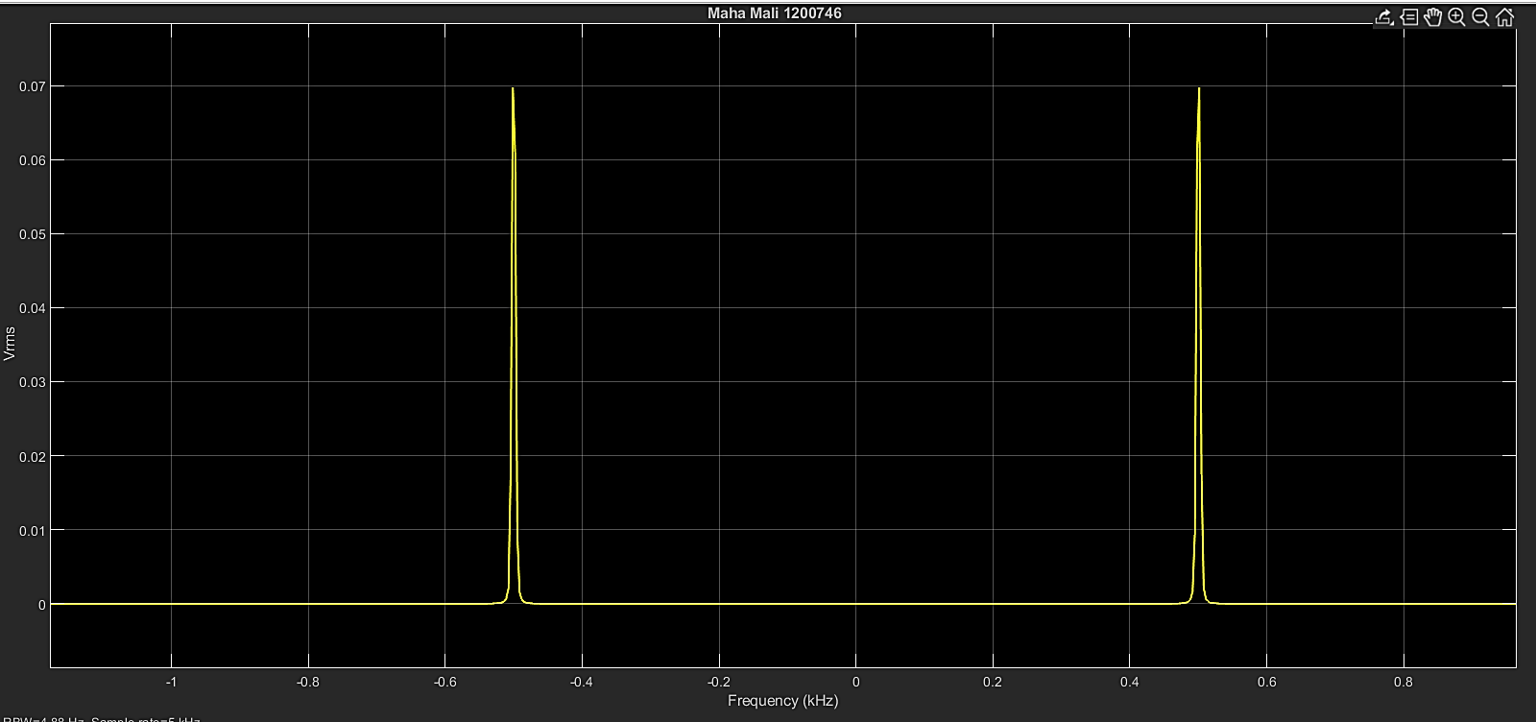

Figure 17: Demodulated signal in time domine

The figure show that the demodulated signal has the same frequency of message signal which is 500 Hz.